# UNIT - III

**Syllabus:** Color Image Processing

Introduction, Color fundamentals, color models, pseudo color image processing, basics of full color image processing, color transformations, color image smoothing and sharpening, color segmentation.

# Introd uction:

* Color of an object is determined by the nature of the light reflected from it.
* When a beam of sunlight passes through a glass prism, the emerging beam of light is not white but consists instead of a continuous spectrum of colors ranging from violet at one end to red at the other.
* As Fig.a shows, the color spectrum may be divided into six broad regions: violet, blue, green, yellow, orange, and red.
* 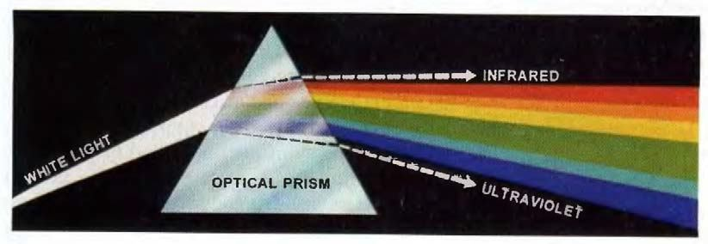When viewed in full color (Fig. b), no color in the spectrum ends abruptly, but rather each color blen ds smoothly into the next.

Fig a: Color spectrum seen by passing white light through a prism

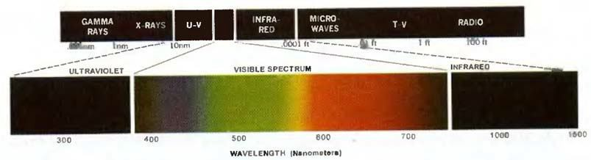Fig. b: Wavelengths comprising the visible range of the electromagnetic spectrum.

* As shown in Fig. b, visible light is composed narrow band of frequencies in the electromagnetic spectrum. A body that reflects light that is balanced in all visible wavelengths appears white to the observer.
* However, a body that favors reflectance in a limited range of the visible spectrum exhibits some shades of color. For examp le, green objects

reflect light with wavelengths primarily in the 500 to 570 nm range while absorbing most of the energy at other wavelengths.

* Characterization of light is central to the science of color. If the light is achromatic (void of color), its only attribute is its **intensity** , or amount. **Achromatic light** is what viewers see on a **black and white television** set.
* Three basic quantities are used to describe the quality of a chromatic light source: radiance, luminance, and brightness.
* **Radiance:** Radiance is the total amount of energy that flows from the light source, and it is usually measured in watts (W).
* **Luminance:** Luminance, measured in lumens (lm), gives a measure of the amount of energy an observer perceives from a light source. For example, light emitted from a source operating in the far infrared region of the spectrum could have significant energy (radiance), but an observer would hardly perceive it; its luminance would be almost zero.
* 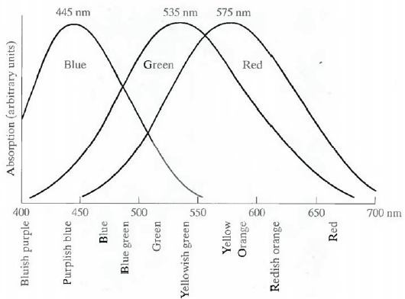**Brightness:** Brightness is a subjective descriptor that i s practically impossible to measure. It embodies the achromatic notion of intensity and is one of the key factors in describing color sensation.

Fig.c Absorption of light by the red, green, and blue cones in the human eye as a function of wavelength.

* Cones are the sensors in the eye responsible for color vision. Detailed experimental evidence has established that the 6 to 7 million cones in the human eye can be divided into three principal sensing categories, corresponding roughly to red, green, and bl ue. Approximately 65% of all cones are sensitive to red light, 33% are sensitive to green light, and only about 2% are sensitive to blue (but the blue cones are the most sensitive). Figure 3 shows average experimental curves detailing the absorption of light by the red, green, and blue cones in the eye. Due to these absorption characteristics of the human eye, colors arc seen as

variable combinations of the so - called primary colors red (R), green (G), and blue (B).

* The primary colors can be added to produce the secondary colors of light

--magenta (red plus blue), cyan (green plus blue), and yellow (red plus green). Mixing the three primaries, or a secondary with its opposite primary color, in the right intensities produces white light.

* The characteristics generally used to distinguish one color from another are brightness, hue, and saturation. **Brightness** embodies the chromatic notion of intensity. **Hue** is an attribute associated with the dominant wavelength in a mixture of light waves. Hue represents dominant color as perceived by an observer. **Saturation** refers to the relative purity or the amount of white light mixed with a hue. The pure spectrum colors are fully saturated. Colors such as **pink** (red and white) and **lavender** (violet and white) are less saturated , with the degree of saturation being inversely proportional to the amount of white light -added.
* Hue and saturation taken together are called **chromaticity** , and. therefore, a color may be characterized by its brightness and chromaticity.
* 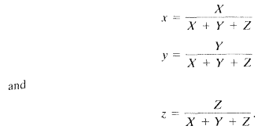The amount of red , green or blue in a color is known as **Tristimulus** Values and they are denoted as X, Y and Z respectively. A color is then specified by its **Trichromatic coefficients** denoted as:
  + It is noted from above equations that *x+y+z=1*
  + For any value of x(red) and y(green) the corresponding value of z(blue) is obtained by above equation as **z=1 -(x+y)**
  1. **Color models**
* The purpose of a color model (also called **color space** or **color system** ) is to facilitate the specification of colors in some standard.
* In essence, a color model is a specification of a coordinate system and a subspace within that system where each color is represented by a single point.
* RGB Model for color monitors and color video cameras.
* CMY and CMYK models for color printing.
* HIS model used by humans to describe and interpret colors of image and also used to decouple the color and grayscale information in an image.

# The RGB Color Model:

* 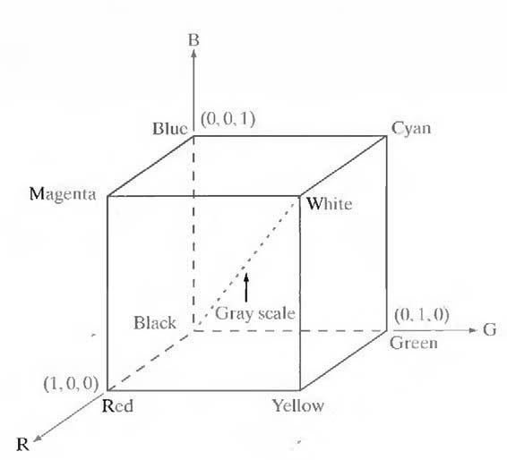In the RGB model, each color appears in its primary spectral components of red, green, and blue. This model is based on a Cartesian coordinate system. The color subspace of interest is the cube shown in Fig 3.2.1, in which RGB values are at three corners; cyan, magenta, and yellow are at three other corners; black is at the origin; and white is at the corner farthest from the origin. In this model, the gray scale (points of equal RGB values) extends from black to white along the line joining these two points. The different colors in this model arc points on or inside the cube, and are defined by vectors extending fr om the origin. For convenience, the assumption is that all color values have been normalized so that the cube shown in Fig.4 is the unit cube. That is, all values of R, G. and B are assumed to be in the range [0, 1].

Fig 3.2.1: Schematic of the RGB color cube

* Images represented in the RGB color model consist of three component images, one for each primary color. When fed into an RGB monitor, these three images combine on the phosphor screen to produce a composite color image. The number of bits used to re present each pixel in RGB space is called the pixel depth.
* Consider an RGB image in which each of the red, green, and blue images is an 8-bit image. Under these conditions each RGB color pixel [that is, a triplet of values (R, G, B)] is said to have a dept h of 24 bits C image planes times the number of bits per plane). The term full -color image is used often to denote a 24 -bit RGB color image. The total number of colors in a 24-bit RGB image is (2 8)3 = 16,777,216.
* RGB is ideal for image color generation (as in image capture by a color camera or image display in a monitor screen), but its use for color description is much more limited.
* Even though each color is represented with 256 different intensities depending on viewer hardware capabilities there are subs et (216) of intensities which are viewed. These subsets of intensities are called **safe RGB colors** or ***all -system -safe colors*** .
* Now the RGB triplets of these safe RGB colors is given as (26)3

# CMY color model:

* Cyan, magenta, and yellow are the secondary colors of light or, alternatively, the primary colors of pigments. For example, when a surface coated with cyan pigment is illuminated with white light, no red light is reflected from the surface. That is, cyan subtracts red light from reflected white light, which itself is composed of equal amounts of red, green, and blue light
* Most devices that deposit colored pigments on paper, such as color printers and copiers, require CMY data input or perform an RGB to CMY conversion internally. This conversion is p erformed using the simple operation (1) where, again, the assumption is that all color values have been normalized to the range [0, 1]. Equation (1) demonstrates that light reflected from a surface coated with pure cyan does not contain red (that is, C = 1 — R in the equation).

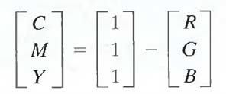

→1

* Similarly, pure magenta does not reflect green, and pure yellow does not reflect blue. Equation (1) also reveals that RGB values can be obtained easily from a set of CMY values by subtracting the individual CMY values from 1. As indicated earlier, in image processing this color model is used in connection with generating hardcopy output, so the inverse operation from CMY to RGB generally is of little practical interest.
* Equal amounts of the pigment primaries, cyan, magenta , and yellow should produce black. In practice, combining these colors for printing produces a **muddy -looking black** .
* To produce true black (predominant colour in printing) a 4th colour, black, is added => CMYK model (CMY + Black)

# HSI color model:

* When humans view a color object, we describe it by its hue, saturation, and brightness. Hue is a color attribute that describes a pure color (pure yellow, orange, or red), whereas saturation gives a measure of the degree to which a pure color is diluted by wh ite light. Brightness is a subjective descriptor that is practically impossible to measure. It embodies the achromatic notion of intensity and is one of the key factors in describing color sensation.
* Intensity (gray level) is a most useful descriptor of mo nochromatic images. This quantity definitely is measurable and easily interpretable. The HSI (hue, saturation, intensity) color model, decouples the intensity component from the color-carrying information (hue and saturation) in a color image. As a result, the HSI model is an ideal tool for developing image processing algorithms based on color descriptions that are natural and intuitive to humans.
* 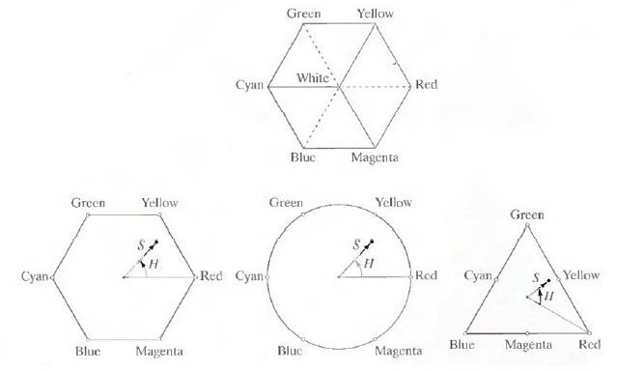In Fig 5 the primary colors are separated by 120°. The secondary colors are 60° from the primaries, which means that the angle between secondaries is also 120°. Figure 3.2.3 (b) shows the same hexagonal shape and an arbitrary color point (shown as a dot).The hue of the point is determined by an angle from some reference point. Usually (but not always) an angle of 0° from the red axis designates 0 hue, and the hue increases counterclockwise from there. The saturation (distance from the vertical axis) is the length of the vector from the origin to the point. Note that the origin is defined by the intersection of the co lor plane with the vertical intensity axis. The important components of the HSI color space are the vertical intensity axis, the length of the vector to a color point, and the angle this vector makes with the red axis.

# Fig 3.2.3: Hue and saturation in the HSI color model.

**Conversion from RGB color model to HSI color model:**

* Given an image in RGB color format, the H component of each RGB pixel is obtained using the equation

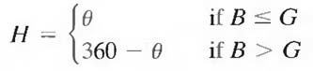

→1

* With

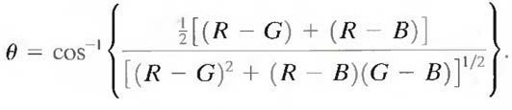

→2

* The saturation component is given by

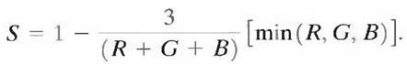

→3

* Finally, the intensity component is given by

→4



* It is assumed that the RGB values have been normalized to the range [0, 1] and that angle θ is measured with respect to the red axis of the HST space. Hue can be normalized to the range [0, 1] by dividing by 360° all values resulting from Eq. (1). The othe r two HSI components already are in this range if the given RGB values are in the interval [0, 1].

# Conversion from HSI color model to RGB color model:

* Given values of HSI in the interval [0, 1], one can find the corresponding RGB values in the same range. The applicable equations depend on the values of H. There are three sectors of interest, corresponding to the 120° intervals in the separation of primaries.

**RG sector (0 o ≤ H <120°):**When H is in this sector, the RGB components are given by the equations

# B = I (1 – S)

**G = 3 I – (R + B)**

# R = I [1 + (S * cos H/ cos(60 o – H)] GB sector (120 o ≤ H < 240o):

If the given value of H is in this sector, first subtract 120° from it.

# H = H - 120 0

Then the RGB components are

# R = I (1 – S)

**B = 3 I – (R + G)**

# G = I [1 + (S * cos H/ cos(60 o – H)] BR sector (240 o ≤ H ≤ 360o):

If H is in this range, subtract 240 o from it

# H = H - 240 0

Then the RGB components are

# G = I (1 – S)

**R = 3 I – (B + G)**

# B = I [1 + (S * cos H/ cos(60 o – H)]

* 1. **Pseudo color image processing**
* Pseudo color (also called false color) image processing consists of assigning colors to gray values based on a specified criterion.
* The term pseudo or false color is used to differen tiate the process of assigning colors to monochrome images from the processes associated with true color images.
* The process of gray level to color transformations is known as pseudo color image processing.
* The two techniques used for pseudo color image processing are,

1. Intensity Slicing
2. Gray Level to Color Transformation

# Intensity Slicing:

* The technique of intensity (sometimes called density) slicing and color coding is one of the simplest examples of pseudo color image processing. If an image is in terpreted as a 3-D function (intensity versus spatial coordinates), the method can be viewed as one of placing planes parallel to the coordinate plane of the image; each plane then "slices" the function in the area of intersection. Figure 3.3.1 shows an example of using a plane at f(x, y) = li to slice the image function into two levels.
* If a different color is assigned to each side of the plane shown in Fig.6, any pixel whose gray level is above the plane will be coded with one color, and any pixel below the plane will be coded with the other. Levels that lie on the plane itself may be arbitrarily assigned one of the two colors. The result is a two-color image whose relative appearance can be controlled by moving the slicing plane up and down the gray -level axis.
* In general, the technique may be summarized as follows. Let [0, L - 1] represent the gray scale, let level lo represent black [f(x, y) = 0], and level *l*L - 1 represent white [f(x, y) = L - 1 ]. Suppose that P planes perpendicular to the intensity axis are defined at levels *l1, l2,….,lp.*. Then, assuming that 0 < P < L – 1, the P planes partition the gray scale into P + 1 intervals, V 1, V2,...,Vp+ 1. Gray-level to color assignments are made according to the relation *f*(x, y) = ck if *f*(x, y) є Vk

Where ck is the color associated with the kth intensity interval V k defined by the partitioning planes at l = k - 1 and l = k.

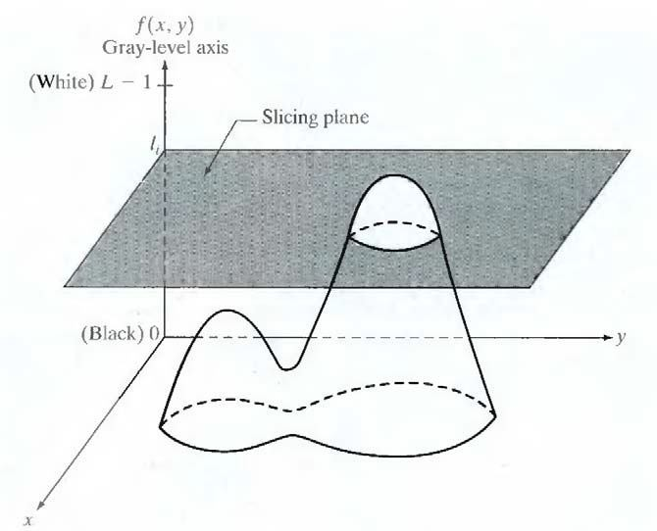Fig.3.3.1: Geometric interpretation of the intensity -slicing technique.

* The idea of planes is useful primarily fo r a geometric interpretation of the intensity slicing technique. Figure shows an alternative representation that defines the same mapping as in Fig 3.3.1 . According to the mapping function shown in Fig , any input gray level is assigned one of two colors, depending on whether it is above or below the value of l i when more levels are used, the mapping function takes on a staircase form.

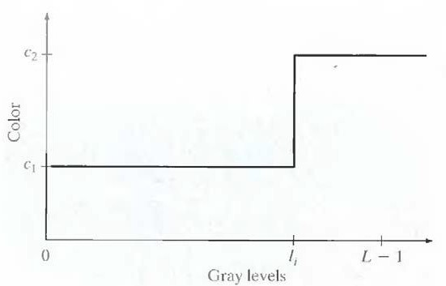

# Fig: An alternative representation of the intensity -slicing technique

* + 1. **Gray Level to Color Transformation:**
* The idea underlying this approach is to perform three independent transformations on the gray level of any input pixel. The three results are then fed separately into the red, green, and blue channels of a color television monitor. This method produces a composi te image whose color content is modulated by the nature of the transformation functions. Note that these are transformations on the gray -level values of an image and are not functions of position.
* 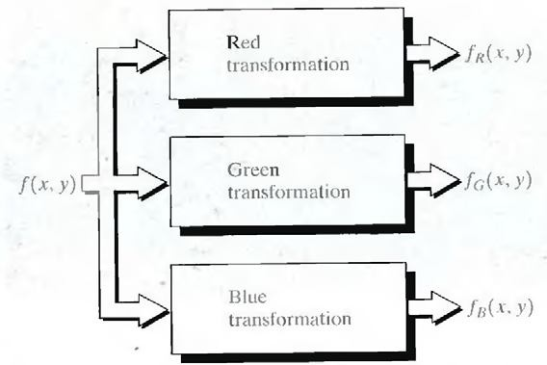In intensity slicing, piecewise linear functions of the gra y levels are used to generate colors. On the other hand, this method can be based on smooth, nonlinear functions, which, as might be expected, gives the technique considerable flexibility.

# Fig 3.3.2 Functional block diagram for pseudocolor image process ing.

* The output of each transformation is a composite image.
  1. **Basics of full co lor image processing**
* Full-color image processing approaches fall into two major categories. In the first category, each component image is processed individually and then form a composite processed color image from the individually processed components. In the second category, one works with color pixels directly. Because full -color images have at least three components, color pixels really are vectors. For example, in the RG B system, each

color point can be interpreted as a vector extending from the origin to that point in the RGB coordinate system.

* Let c represent an arbitrary vector in RGB color space:

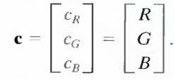

→1

* 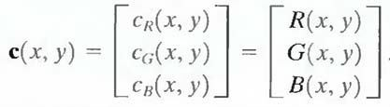This equation indicates that the components of c are simply th e RGB components of a color image at a point. If the color components are a function of coordinates (x, y) by using the notation

----→2

* For an image of size M X N, there are MN such vectors, c(x, y), for x = 0,1, 2,...,M- l; y = 0,1,2,...,N- 1.
* It is important to keep clearly in mind that Eq. (2) depicts a vector whose components are spatial variables in x and y.
* 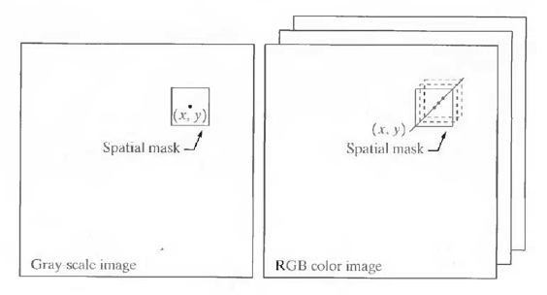In order for per -color-component and vector -based processing to be equivalent, two conditions have to be satisfied: First, the process has to be applicable to both vectors and scalars. Second, the operation on each component of a vector must be independent of the other components.

# Fig 3.4 Spatial masks for gray -scale and RGB color images.

* Fig 3.4 shows neighborhood spatial processing of gray -scale and full- color images. Suppose that the process is neighborhood averaging. In Fig. (a), averaging would be accomplished by summing the gray levels of all the pixels in the neighborhood and dividing by the total number of pixels in the neighborhood. In Fi g. (b), averaging would be done by summing all the vectors in the neighborhood and dividing each component by the total number of vectors in the neighborhood. But each component of the average vector is the sum of the pixels in the image corresponding to t hat component, which is the same as the result that would be obtained if the averaging were done on a per -color-component basis and then the vector was formed.

# Color transformations:

1. **Formulation:**

* As with the gray-level transformation techniques we model color transformations using the expression g(x,y)=T[f(x,y)].
* Where f(x,y) is a color input image. G(x,y) is transformed image. T is an operation on f over a spatial neighborhood of (x,y).
* The principle difference between color image trans formation and gray- level image trans formation is that in color image transformation the pixel value is **triplets or quartets**
* {T1,T2,T3,…,Tn} is a set of transformation or color mapping functions that operate on ri to produce S i .
* If the RGB color space is selecte d, for example, n=3 and r 1,r2, and r3 denote the red, green, and blue components of the input image.
* Suppose, for example, that we wish to modify the intensity of the image using *g*(*x*, *y* ) = *kf* (*x*, *y* )
* In the HIS color space, this can be done with the simple transformation

s3 = kr3 where s1 = r1 and s2 = r2. Only HSI intensity component r3 is modified

* In the RGB color space, three components must be transformed: si = kri for i =1,2,3
* The CMY space requires a similar set of linear transformations: si = kri + (1− k) for i =1,2,3

# Color complements

* 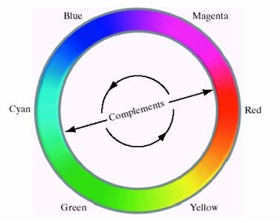The Hues directly opposite one another on the color circle are called the complements as shown in the following figure

Our interest in complements stems from the fact that they are Analogous to gray scale negatives.

As the gray scale case color complements are used to enhance details buried in dark regions of a color image

* 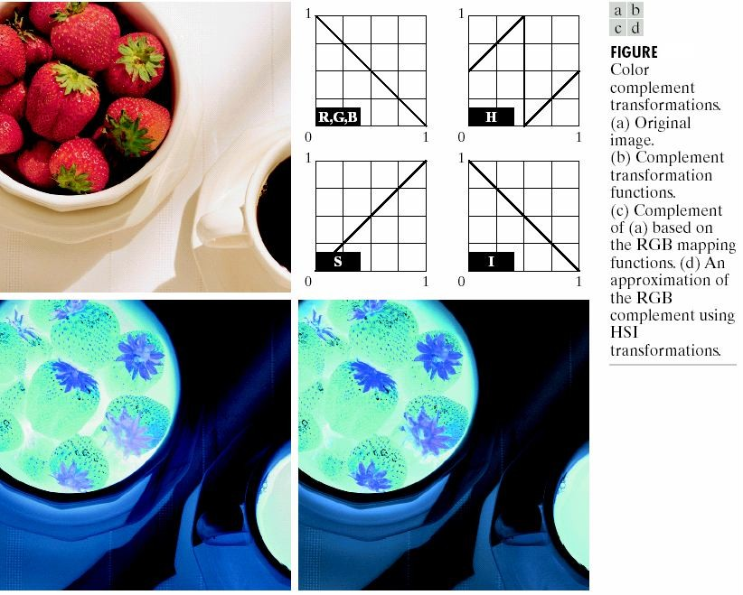The RGB compliment transformation function used in this may not have a straight forward HIS space equivalent.
* Saturation component of the compliment cannot be computed from the saturation component of the input image alone.
* In the above Figures C and D the saturation component is unaltered

# Color slicing

* Color slicing is used to highlight a specific range of colors in an image to separate objects from surroundings.
* The basic idea to this is:
  1. Display the colors of interest so that they stand out from the background. or
  2. use the regions defined by specified colors as a mask for further processing
* – since a color pixel is n -dimensional quantity color transformation functions are more complex than gray -level slicing.
* One simple way to slice the color image is to map the color outside some range of interest to a non prominent natural color.
* Using a cube of width W to enclose the reference color with components (a1,a2, ,an) the transformation is given

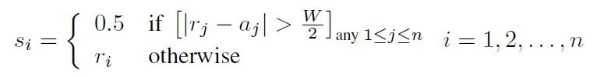by

* These transformations highlight the colors around the prototype by forcing all other colors to the midpoint of the reference color space.
* For RGB color space, for example, a suitable neu tral point is middle gray or color (0.5, 0.5, 0.5).
* If the color of interest is specified by a sphere of radius R0, the ransformation is

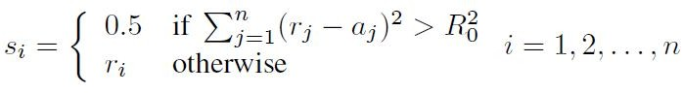

* Here R 0 is the radious of the enclosing sphere and (a 1,a2,a3,…..an) are components of its center.

# Tone and color corrections

* This is used for photo enhancement and color reproduction
* This is Device independent color model from CIE relating the color gamuts
* It use a color profile to map each device to color model
* CIE L*a*b* system
* CIE systm is most common model for c olor management systems
* 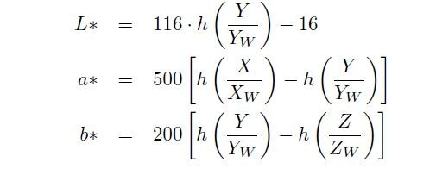For CIE system Components given by the following equations

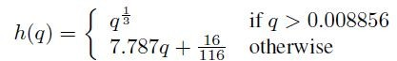Where

* + XW, YW, and ZW are values for refence white, called D65 which is defined by x = 0:3127 and y = 0:3290 in the CIE chromaticity diagram
  + 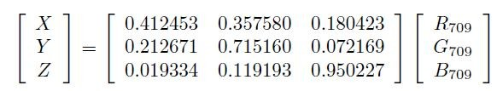X, Y, Z are computed from rgb values as
* Rec. 709 RGB corresponds to D65 white point
* L*a*b* is calorimetric (colors perceived as matching are encoded identically), perceptually uniform (color differences among various hues are perceived uniformly), and device independent
* Not directly displayable on any device but its gamut covers the entire visible spectrum
* L*a*b* decouples intensity from color, making it useful for image manipulation (hue and contrast editing) and image compression applications
* L* represents lightness or intensity
* a* gives red minus green
* b* gives green minus blue
* Allows tonal and color imbalances to be corrected interactively and independently
  + Tonal range refers to general distribution of key intensities in an image
    - Adjust image brightness and contrast to provide m aximum detail over a range of intensities
    - The colors themselves are not changed

# Histogram processing

* This provides an automated way to perform enhancement
* This is simmilar to the grayscale image Histogram equalization
* Adapt the grayscale technique to m ultiple components
* Applying grayscale techniques to different colors independently yields erroneous colors
* Spread the intensities uniformly leaving the hues unchanged.

# 6 Smoothing and sharpening Color image smoothing

* Extend spatial filtering mask to co lor smoothing, dealing with component vectors
* Let S xy be the neighborhood centered at (x, y)
* 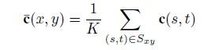Average of RGB components in the neighborhood is given by

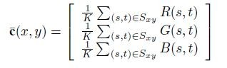Which is the same as

# Color image sharpening:

* + Image sharpening is done using the Laplacian. For vector analysis we know that the Laplacian of a vector is defined as a vector whose components are equal to the laplacian of the individual scalar components of the input vector.
  + 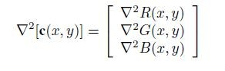In RGB color system the Laplation of vector e is as follows
  + It tells us that we c an compute the Laplation of full color image by computing the Laplacian ofeach component image separately.
  1. **Color segmentation**
* Segmentation is a process that partitions an image into regions.
* Partitioning an image into regions based on color is known as color segmentation.

# Segmentation in HSI Color Space:

* If anybody want to segment an image based on color, and in addition, to carry out the process on individual planes, it is natural to think first of the HSI space because color is conveniently represe nted in the hue image.
* Typically, saturation is used as a masking image in order to isolate further regions of interest in the hue image.
* The intensity image is used less frequently for segmentation of color images because it carries no color information.

# Segmentation in RGB Vector Space:

* Although, working in HSI space is more intuitive, segmentation is one area in which better results generally are obtained by using RGB color vectors.
* Suppose that the objective is to segment objects of a specified color range in an RGB image. Given a set of sample color points representative of the colors of interest, we obtain an estimate of the "average" color that we wish to segment. Let this average color be denoted by the RGB vector a.
* 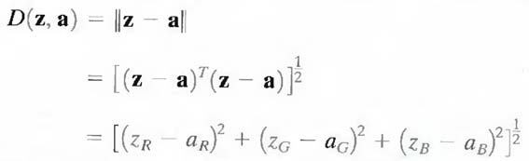The objective of segmentation is to classify each RGB pixel in a given image as having a color in the specified range or not. In order to perform this comparison, it is necessary to have a measure of similarity. One of the simplest measures is the Euclidea n distance. Let z denote an arbitrary point in RGB space. z is similar to a if the distance between them is less than a specified threshold, D o. The Euclidean distance between z and a is given by
* where the subscripts R, G, and B, denote the RGB component s of vectors a and z .The locus of points such that D(z, a) ≤ Do is a solid sphere of radius D o.

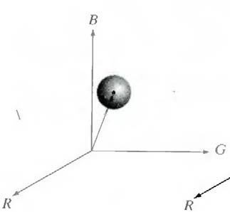

* Points contained within or on the surface of the sphere satisfy the specified color criterion; points outside the sphere do not. Coding these

two sets of points in the image with, say, black and white, produces a binary segmented image.

* A useful generalization of previous equation is a distance measure of the form D (z, a) = [(z-a) T C-1 (z-a)] ½
* Where C is the covariance matrix1 of the samples representat ive of the color to be segmented.
* The above equation represents an ellipse with color points such that D(z, a ) ≤ Do.

# UNIT -I II

**Assignment -Cum-Tutorial Questions Section - A**

## Objective Questions

1. color spectrum is divided into **_ _**broad regions [ ] a.3 b.6 c.9 d.12
2. The amount of energy an observer perceives from a light source is called

[ ]

a. Radiance b. Luminance c. Brightness d. Both A and B

|  |  |  |
| --- | --- | --- |
| 1. Primary colors are   a. RGB b. CMY | c. CMYK | [ ]  d. None |
| 4. Secondary colors are |  | [ ] |
| a. RGB b. CMY | c. Both A and B | d. None |

1. The characteristics generally used to distinguish one col or from another are

[ ]

a. Brightness b. Hue c. Saturation d. All

1. Black level is represented by formula [ ] a. [ƒ (x) = 0] b.[ƒ(y) = 0] c.[ƒ(x,y) = 0] d.[ƒ(x,y) = 1]
2. White color in a Cartesian coordinate system can be represente d as

[ ]

a. (0,1,1) b. (0,1,0) c.(0,0,1) d.(1,1,1)

1. If normalized RGB image intensities are R=G=B=0, after converting the RGB image to HSI format what is S value. [ ]

a. 1 b. 0 c.0.5 d. 2

1. If H Component of RGB Pixel is obtained as θ By_ [ ]

a. H=θ if B<=G b. H=360-θ if B>G c. H=θ if B>=G d. Both A and B

1. If normalized RGB image intensities are R=G=B=1, after converting the RGB image to HSI format what is I value. [ ]

a. 1 b. 0 c. 0.5 d. not determined

1. For any value of x(red)=.3 and y(green)=.6 the corresponding value of z(blue) is _ [ ]

a. 0.9 b. 0 c. 1 d. 0.1

1. Represent Bright green in Hex number system [ ] a. (00FF00) b. (11FF11) c.(11FF00) d. (00FF11)
2. (FFFFFF) 16 is represent _color in RGB format [ ]

a. White b. Black c. red d. both A and B

## SECTION -B

***Descriptive Questions***

1. Explain about color fundamentals.
2. Illustrate RGB color model.
3. Explain CMY color model.
4. Explain HSI color model.
5. Explain about pseudocolor image processing.
6. Summarize color segmentation process.
7. Outline the basics of full color image processing.
8. Demonstrate image smoothing and image sharpening
9. Summarize color transformatio ns